**LAB REPORT**

**Software Project Management**

**Student Name:** Nguyễn Văn Minh

**ID:** 22003405

**Class:** DHKTPM18

**Course:** 2025-2026

Contents

Module 1: 3

Exercise 1: Creating a link 3

Exercise 2: Setting duration 3

Exercise 3: Creating phases 6

Exercise 4: Noah - Linking 8

Exercise 5: Pyramid - Multi level grouping 10

Exercise 6: Creating a plan for Staff Training 12

Exercise 7: Recurring Tasks 14

Exercise 8: Travelling – tasks calendar 16

# Module 1:

## Exercise 1: Creating a link

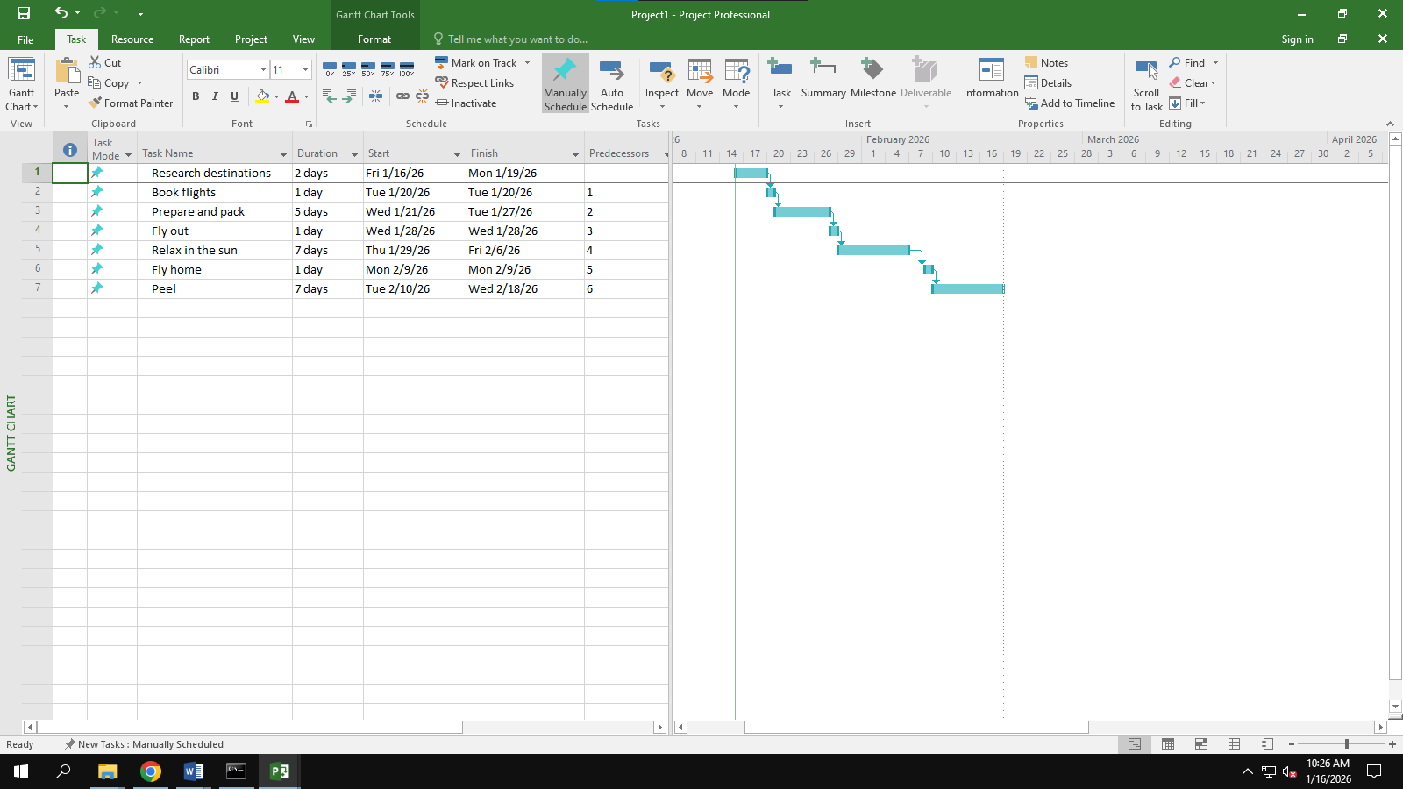

## 

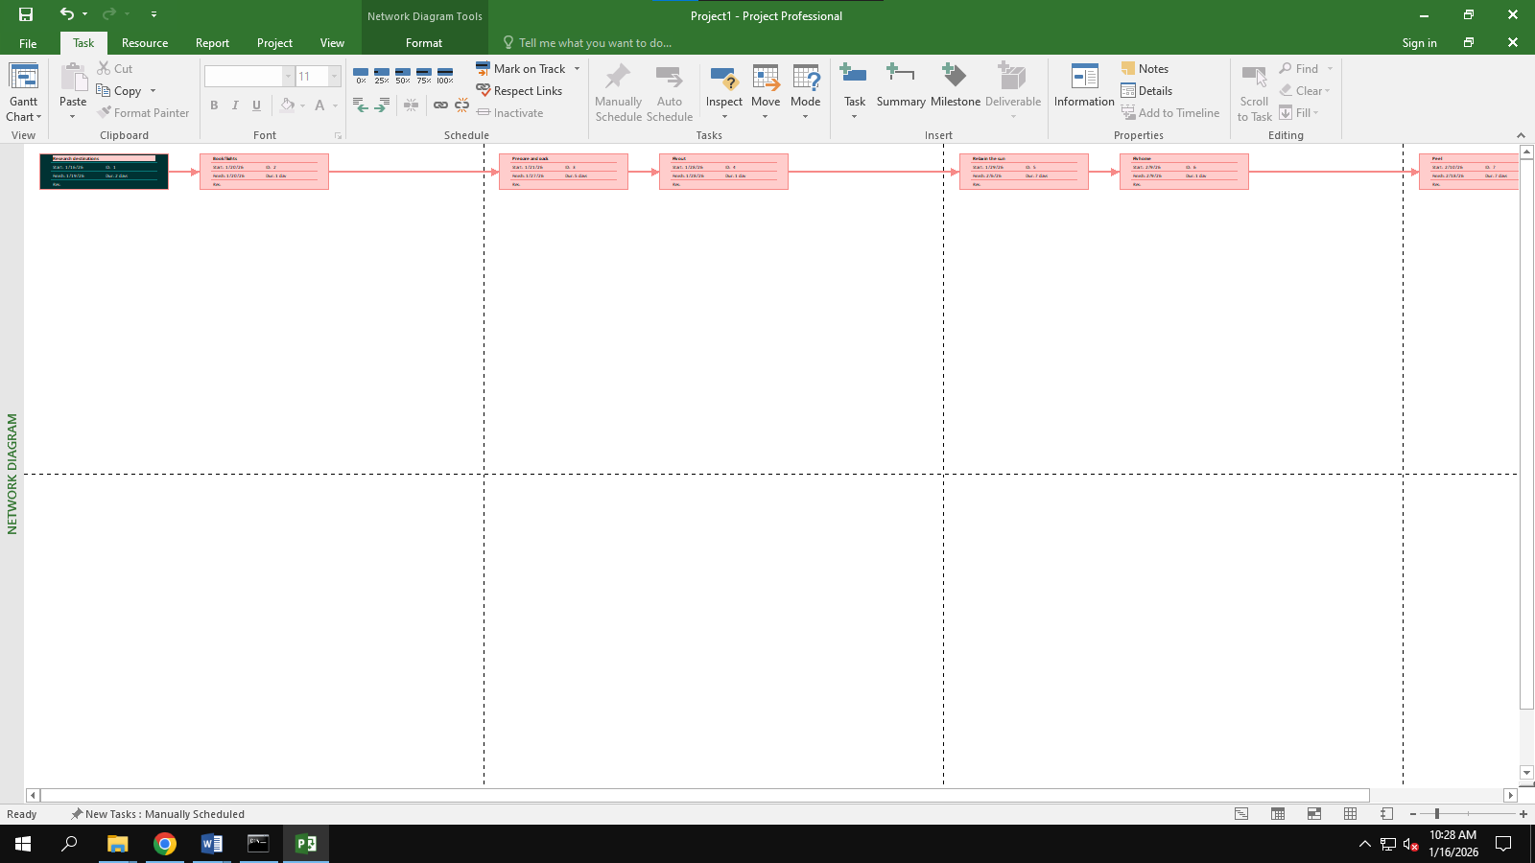

## Exercise 2: Setting duration

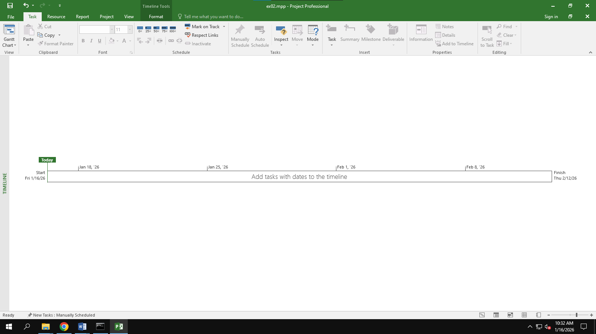

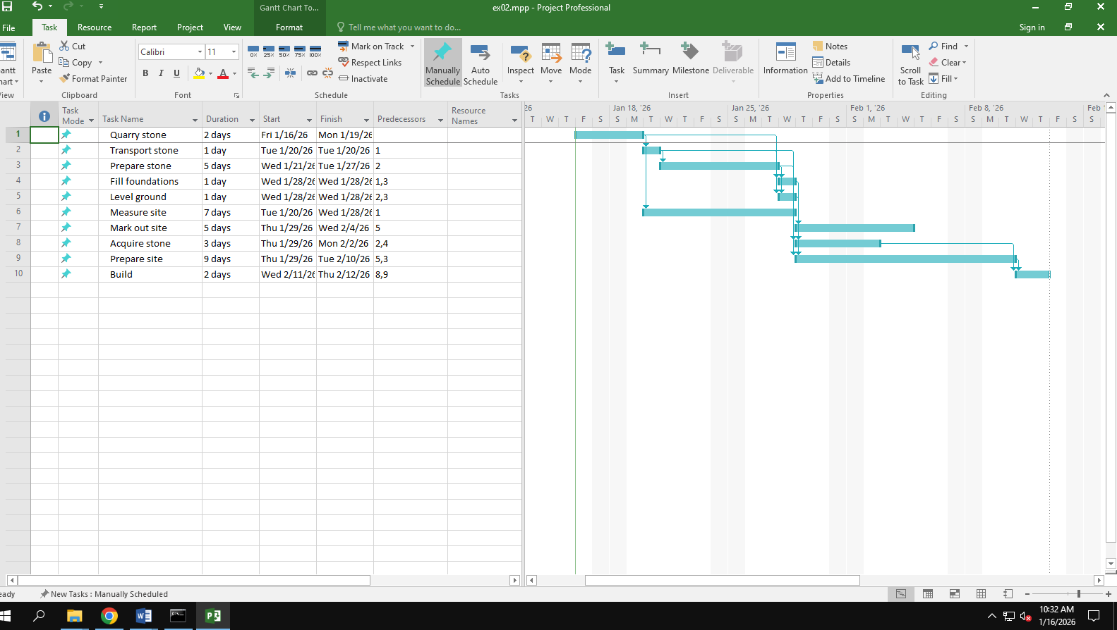

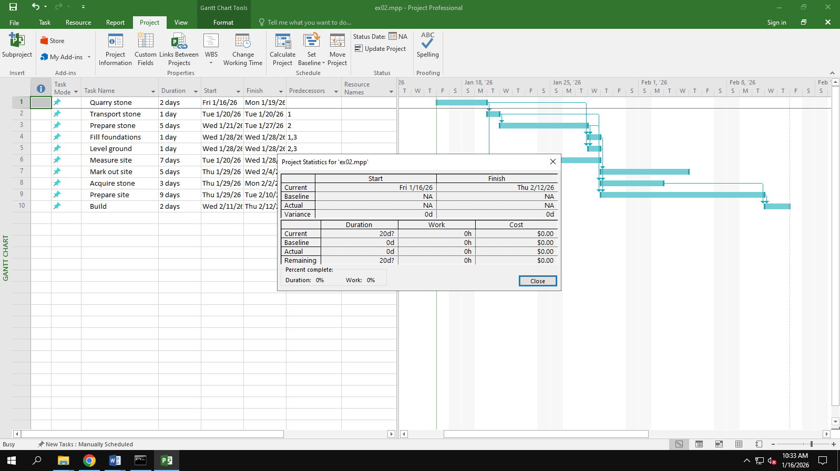

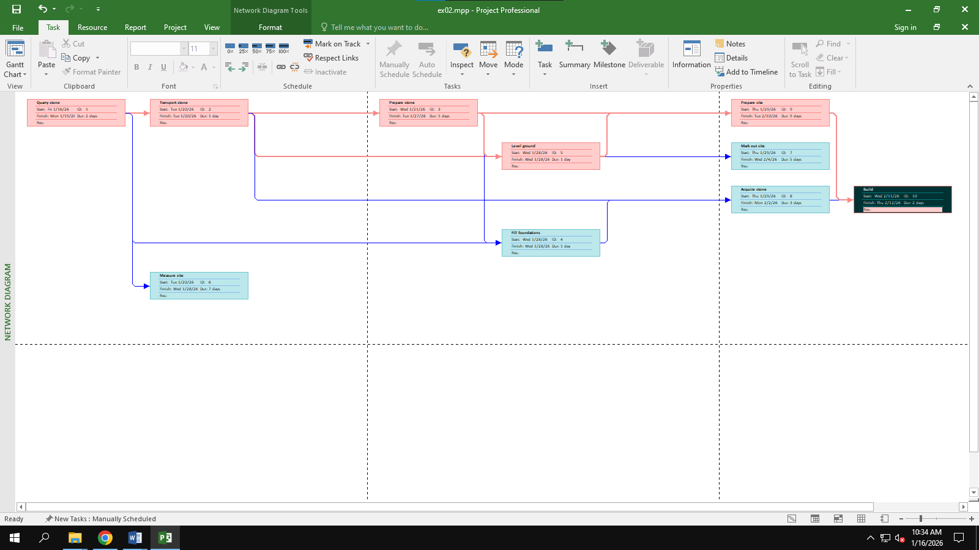

## Exercise 3: Creating phases

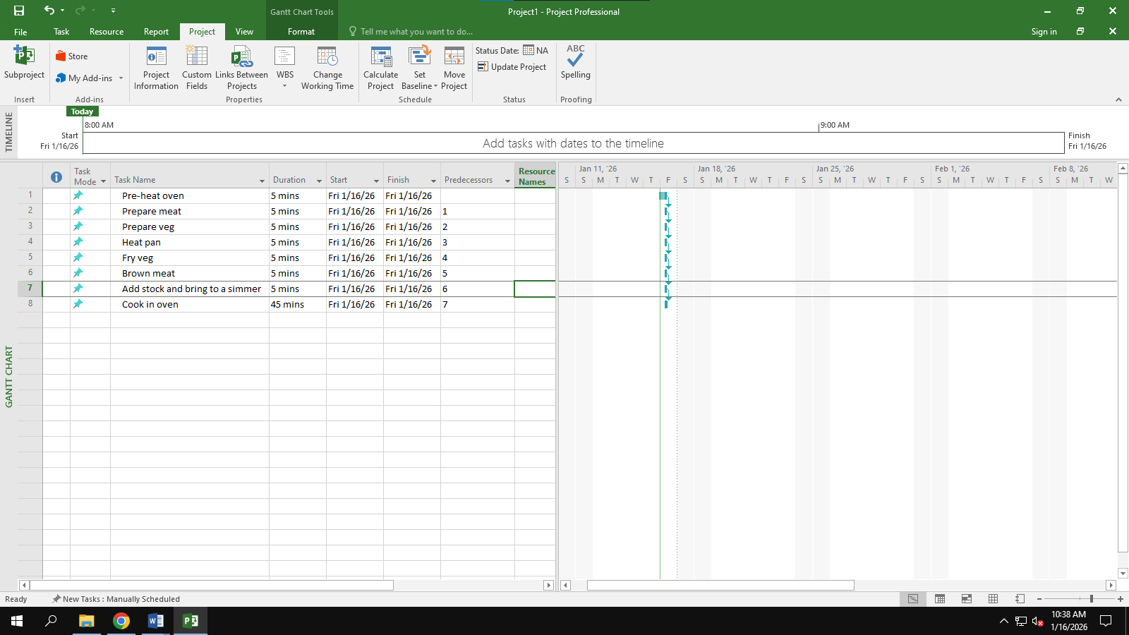

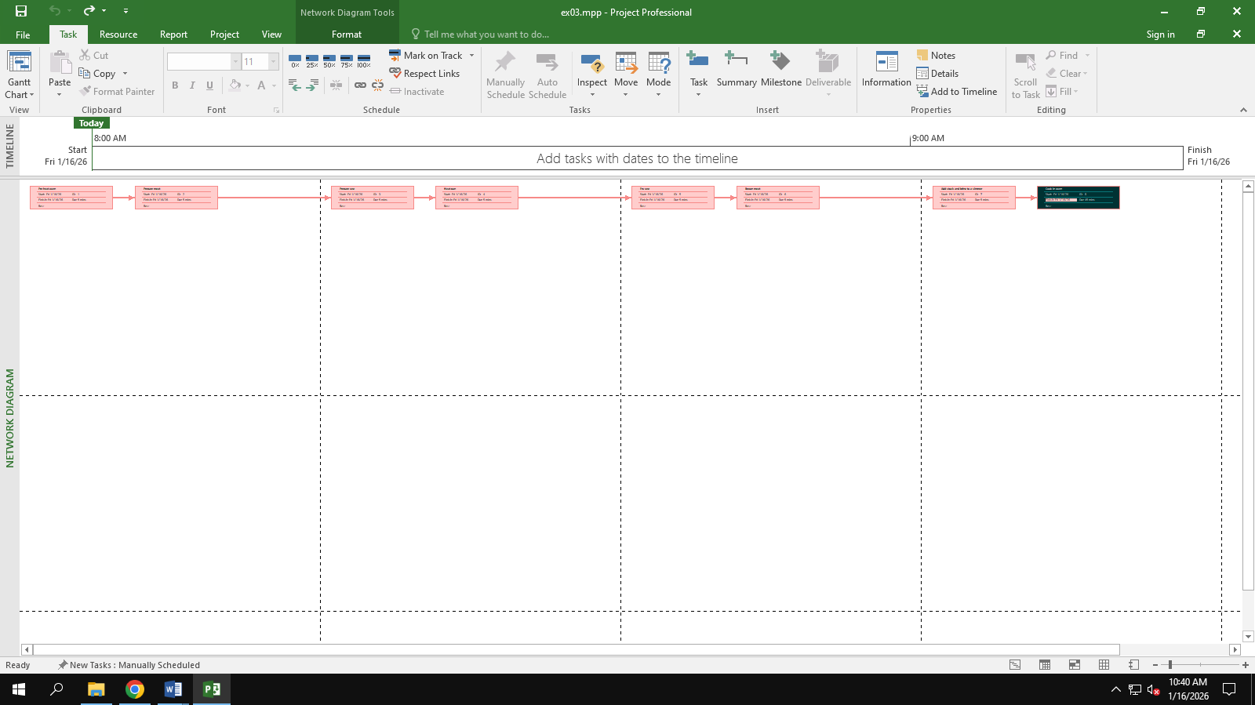

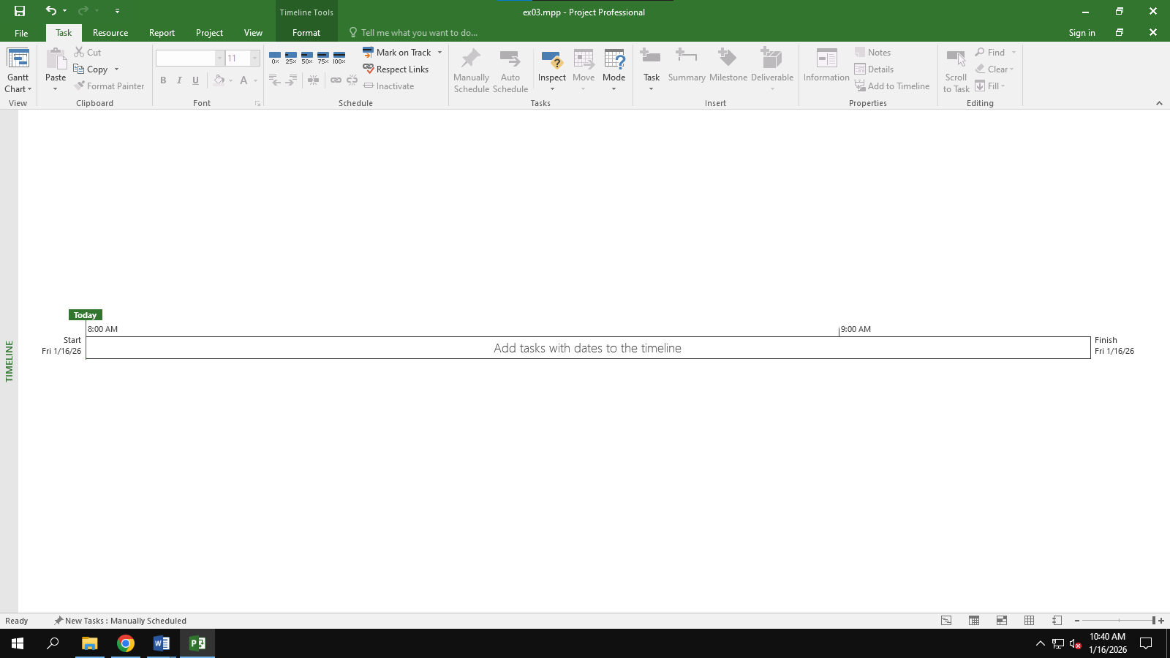

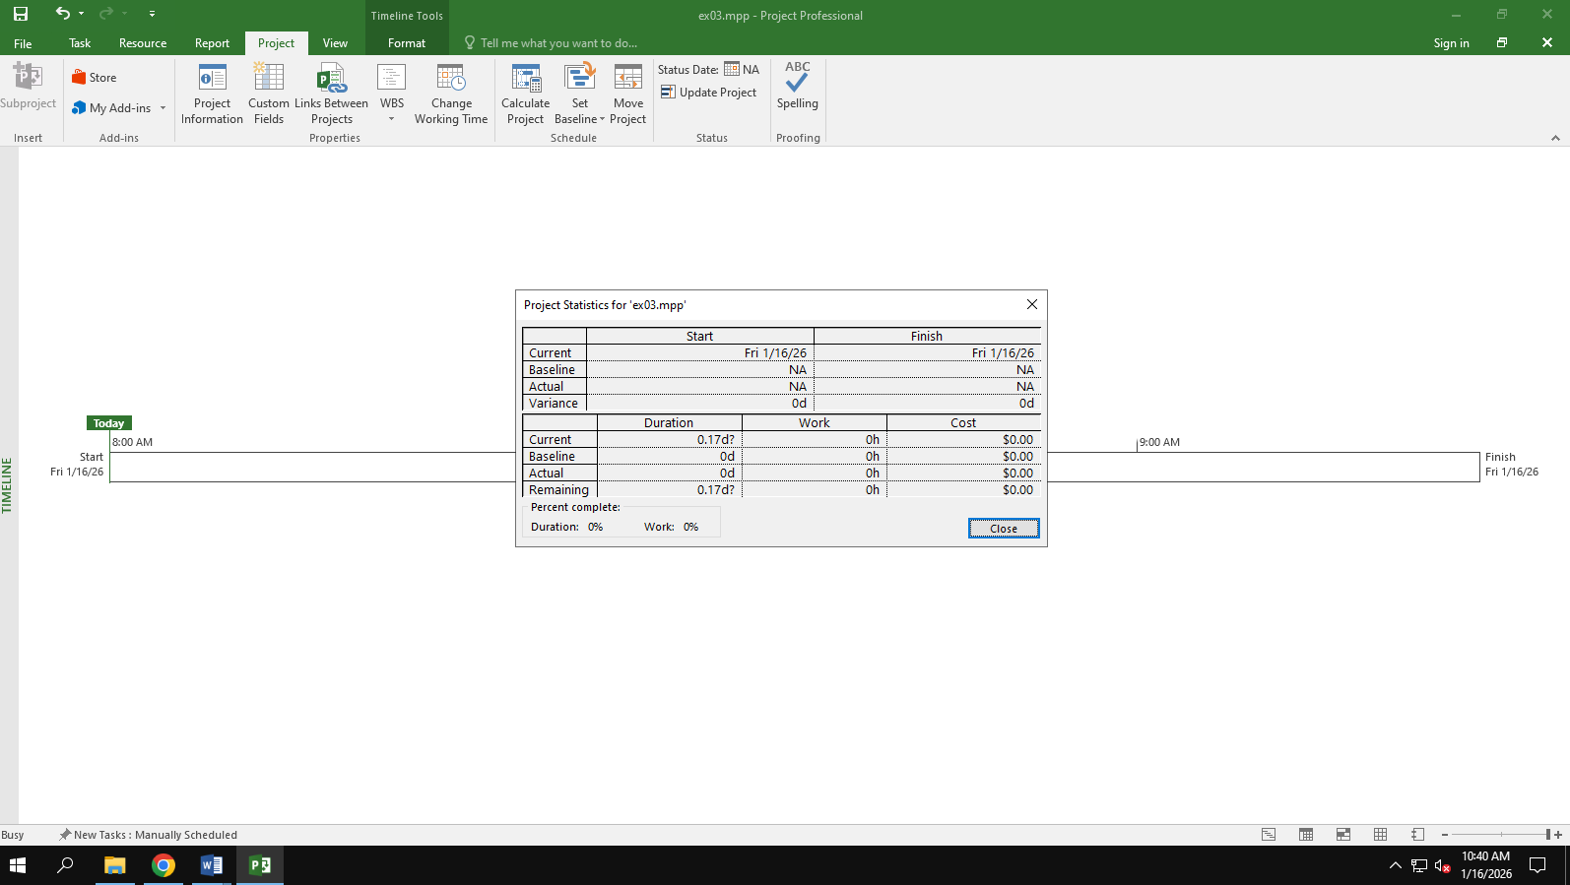

## Exercise 4: Noah - Linking

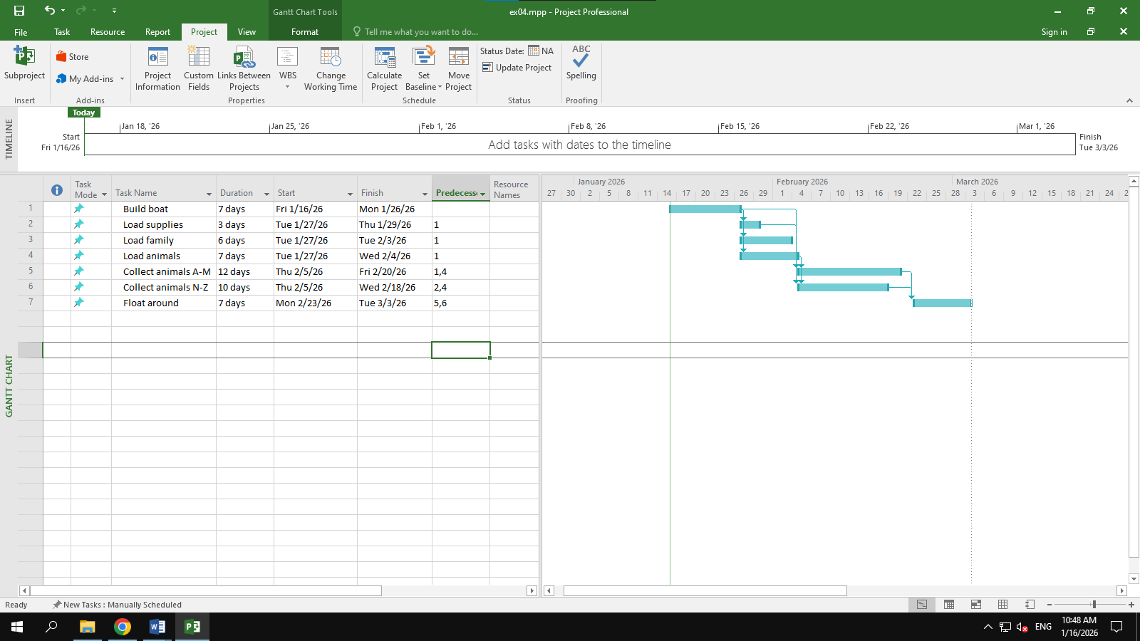

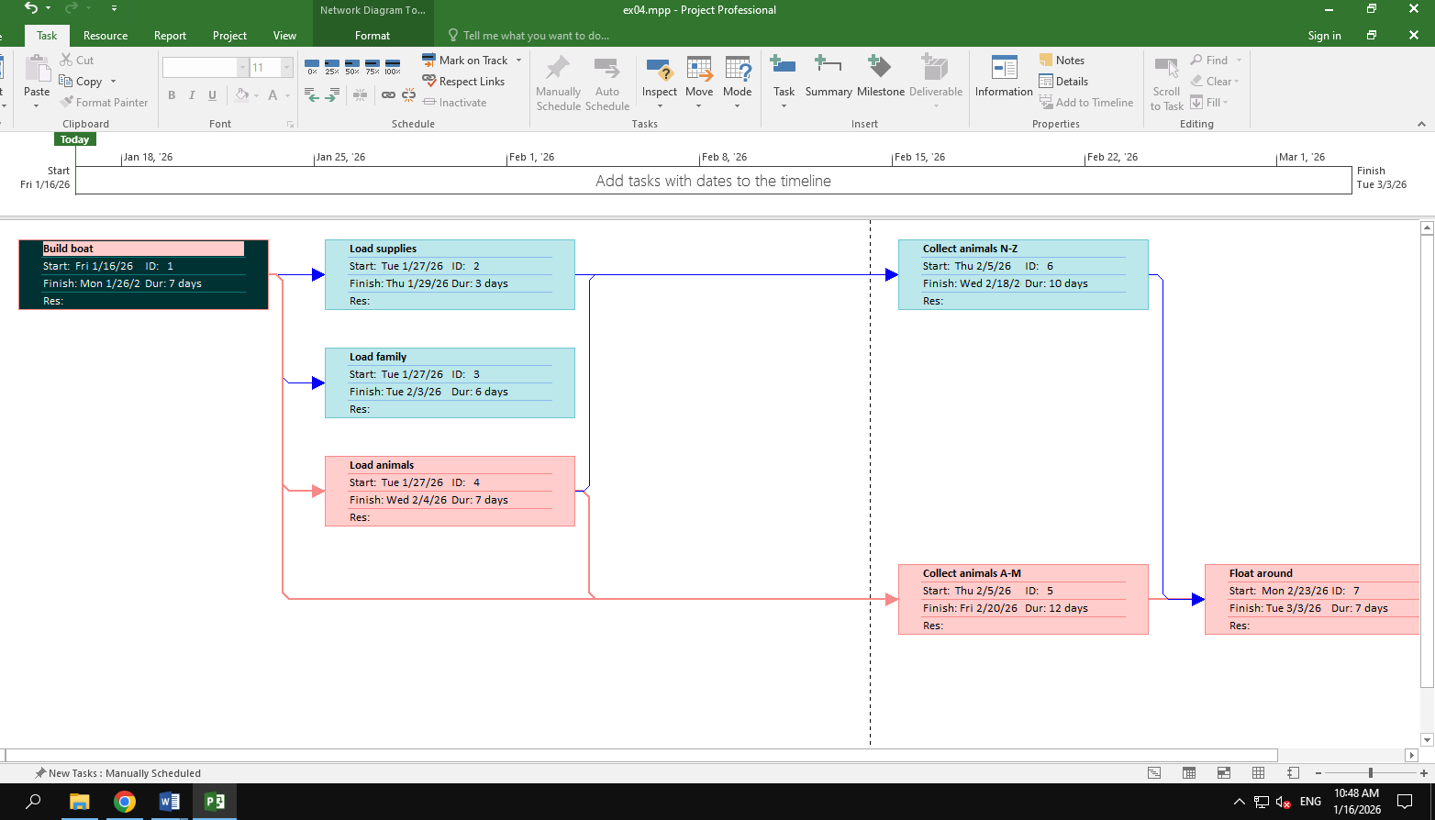

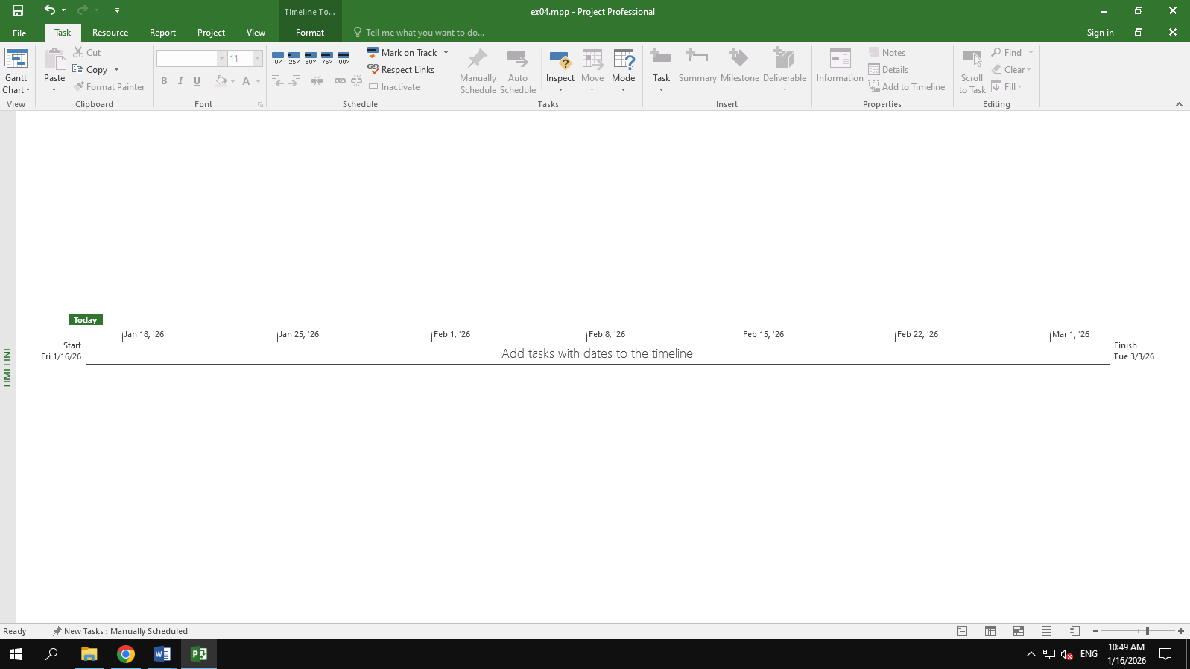

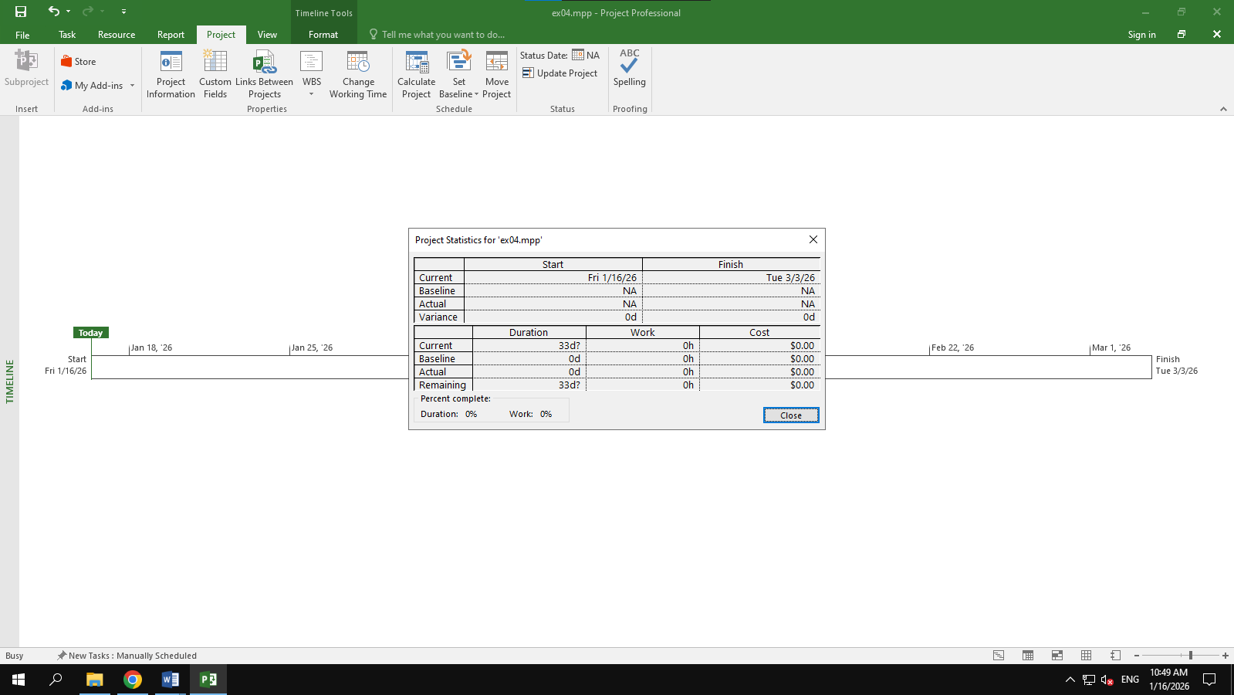

## Exercise 5: Pyramid - Multi level grouping

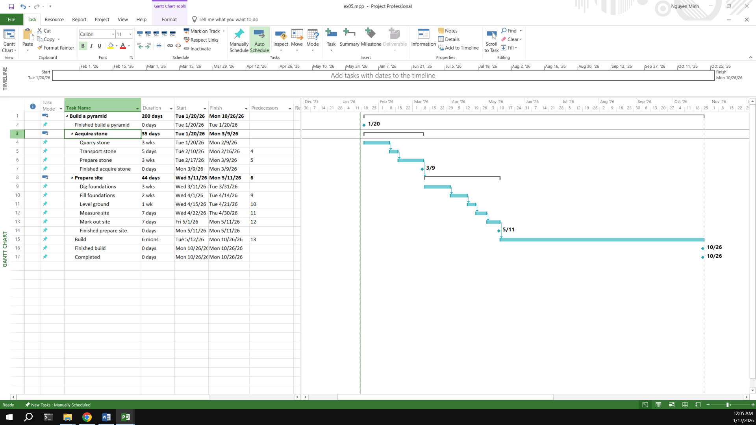

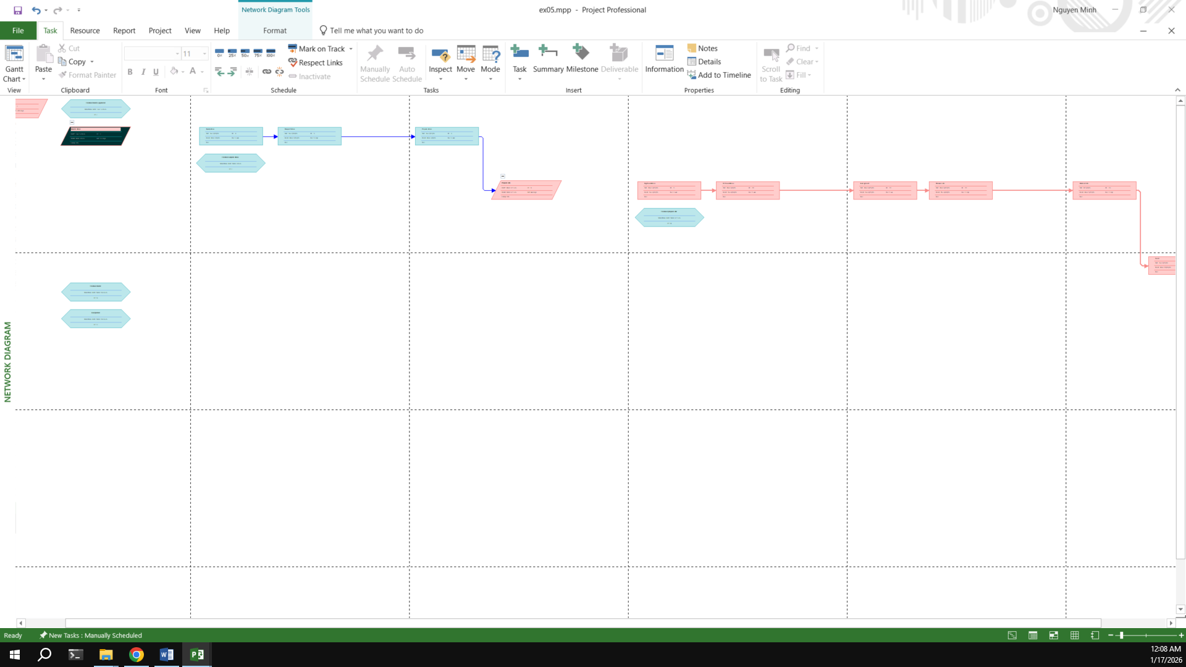

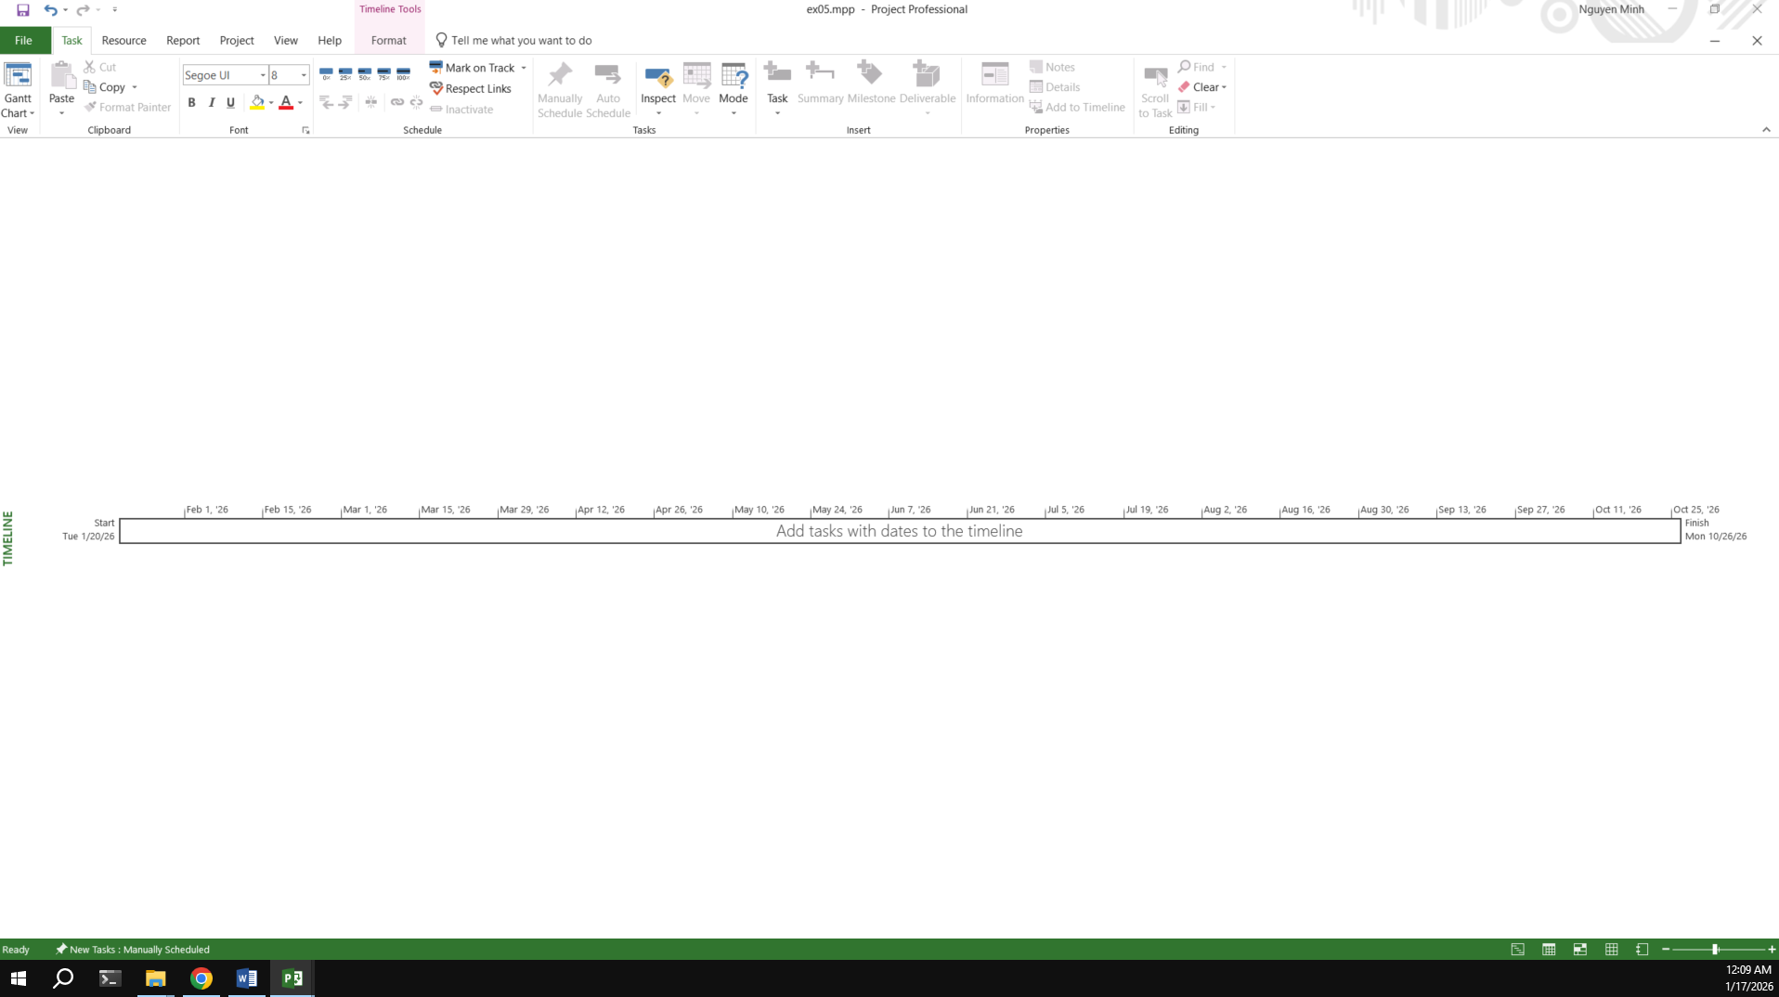

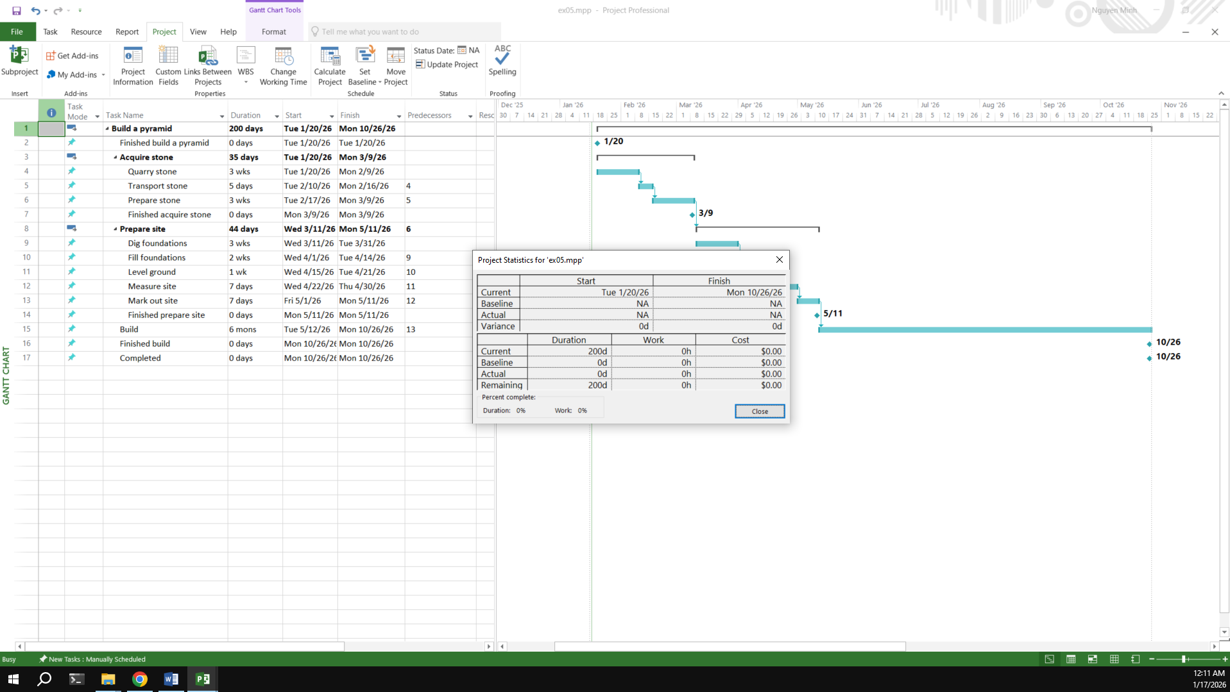

## Exercise 6: Creating a plan for Staff Training

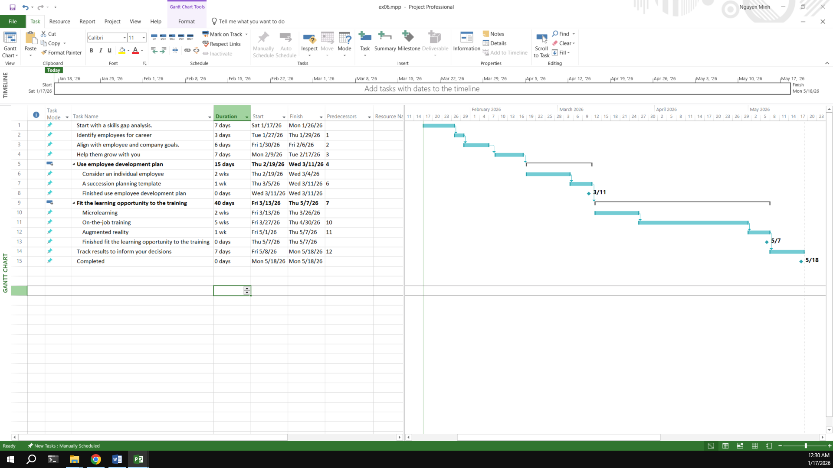

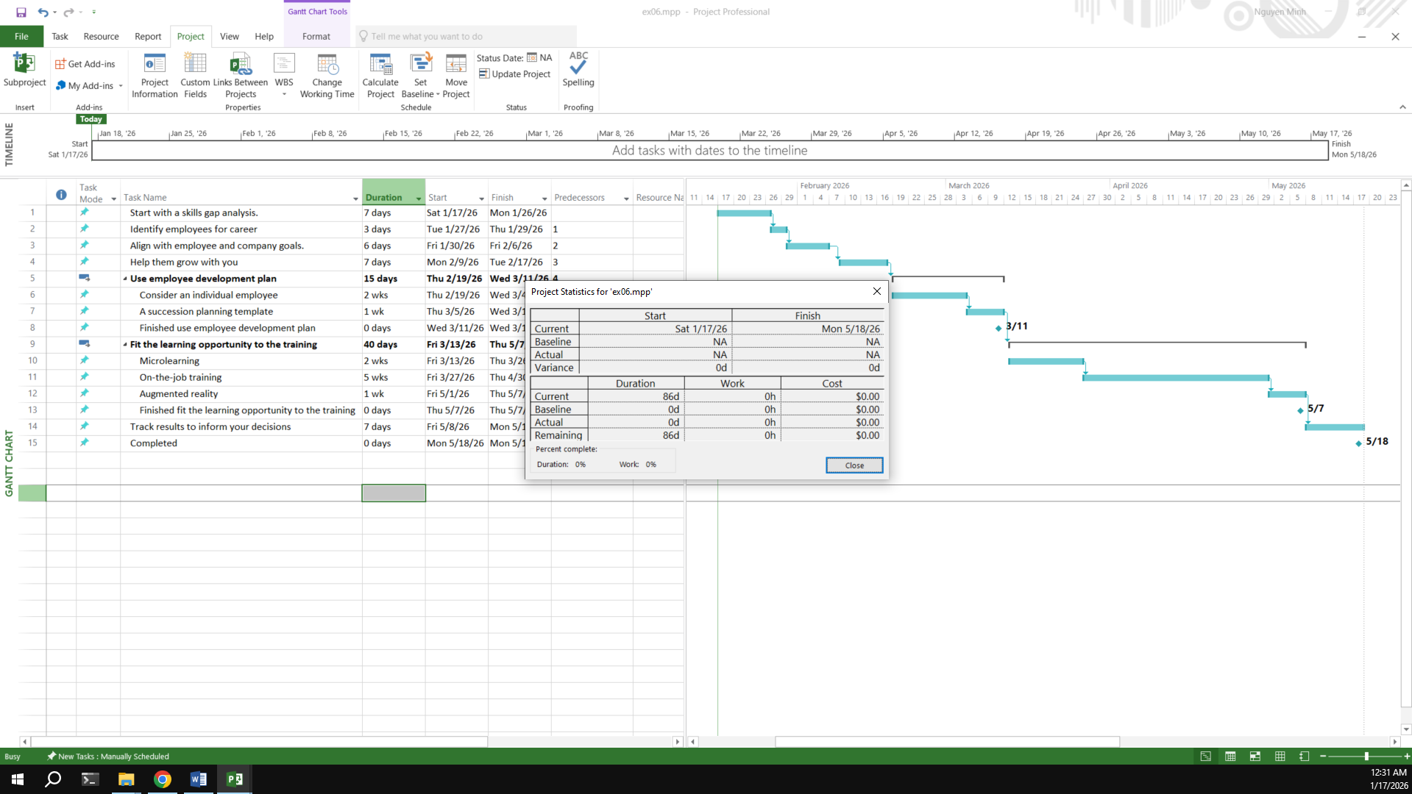

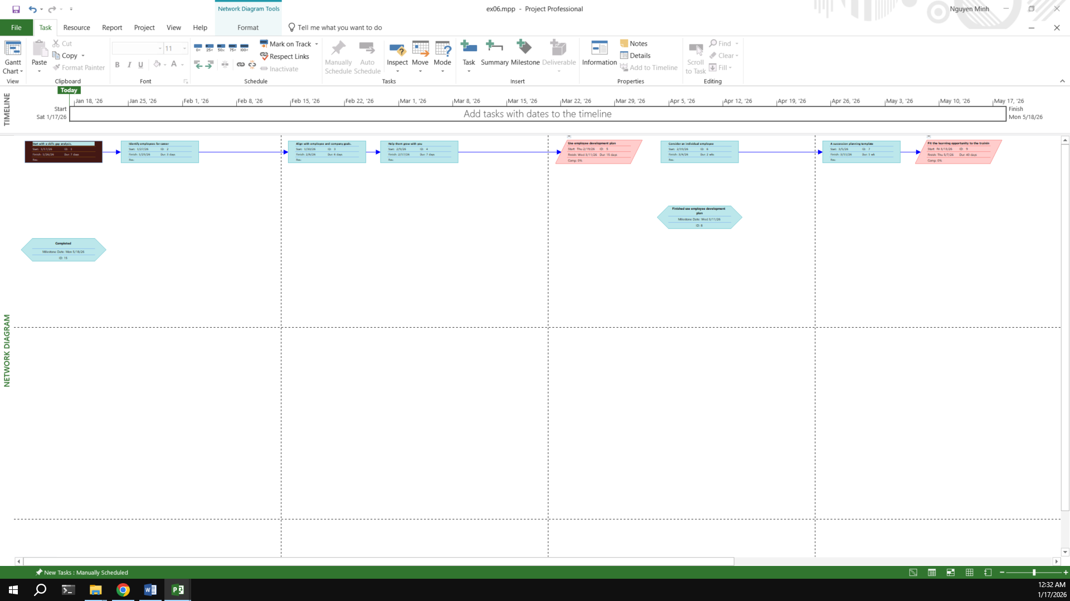

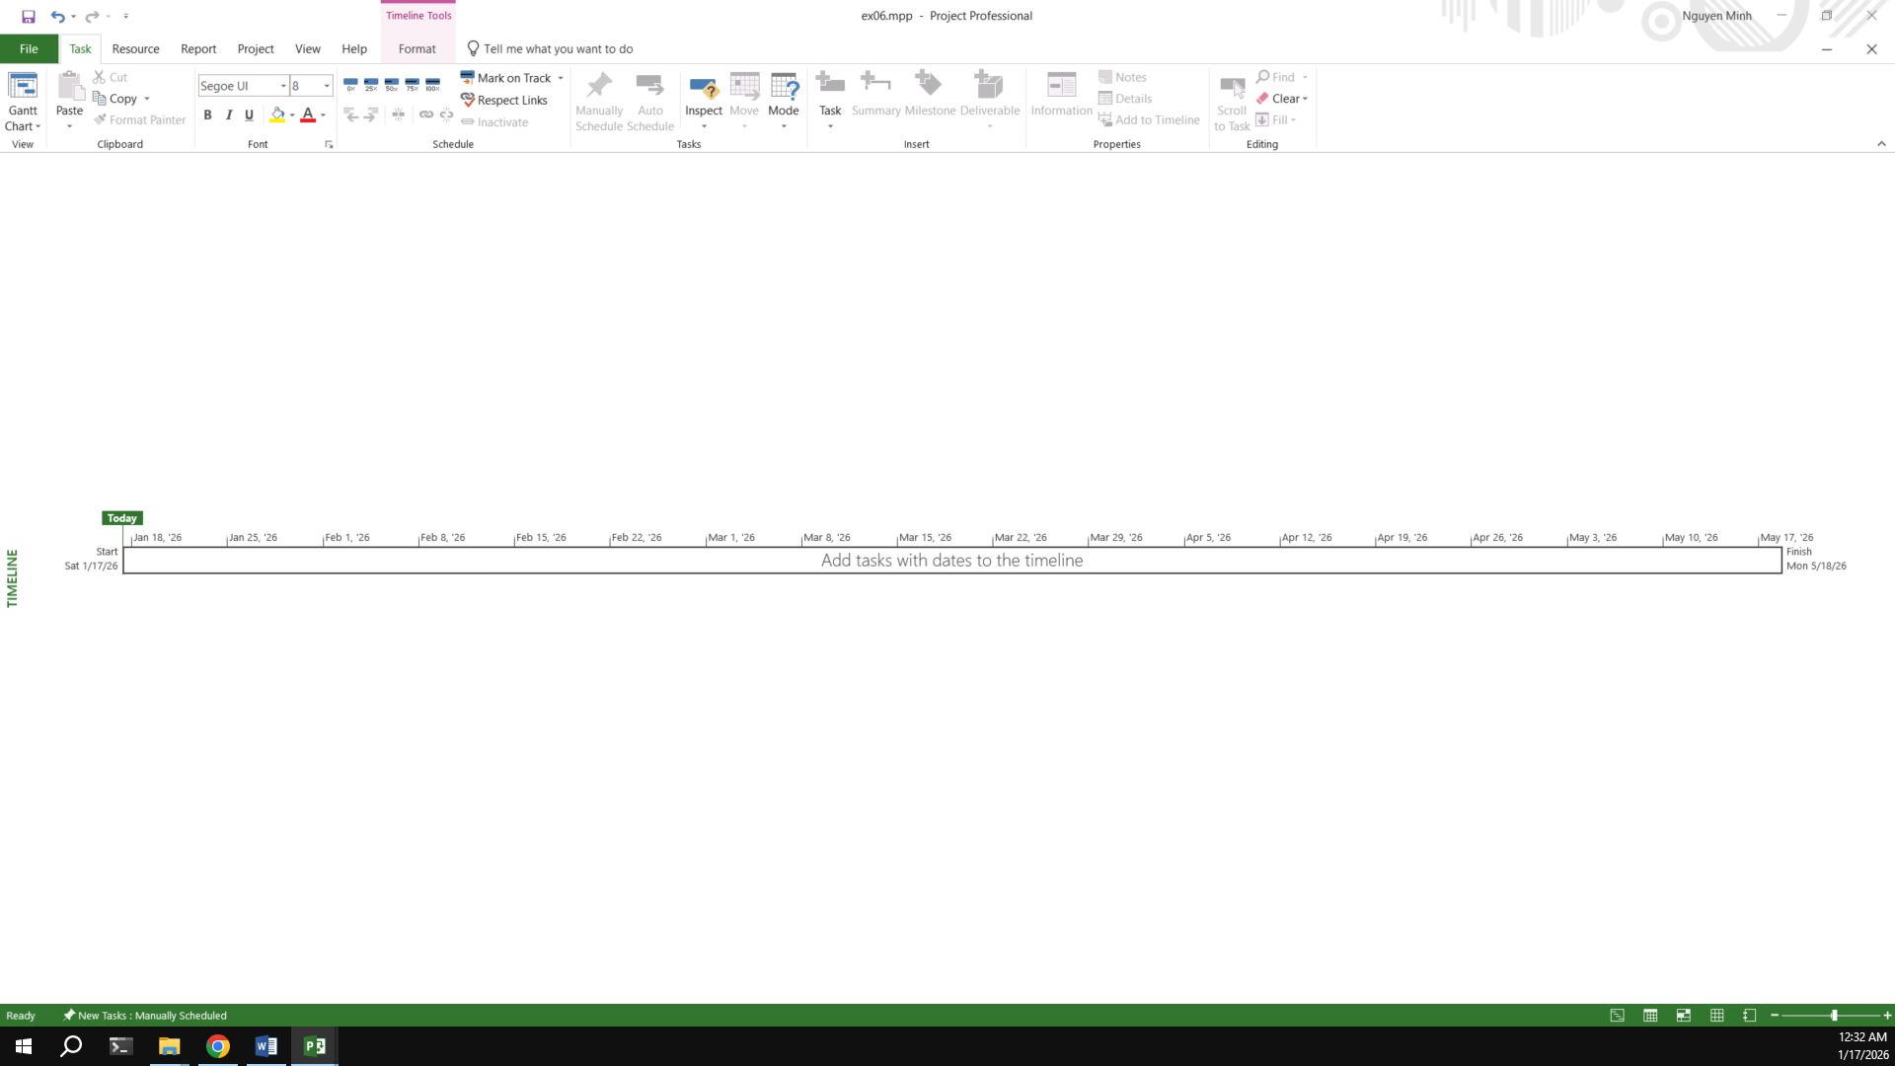

## Exercise 7: Recurring Tasks

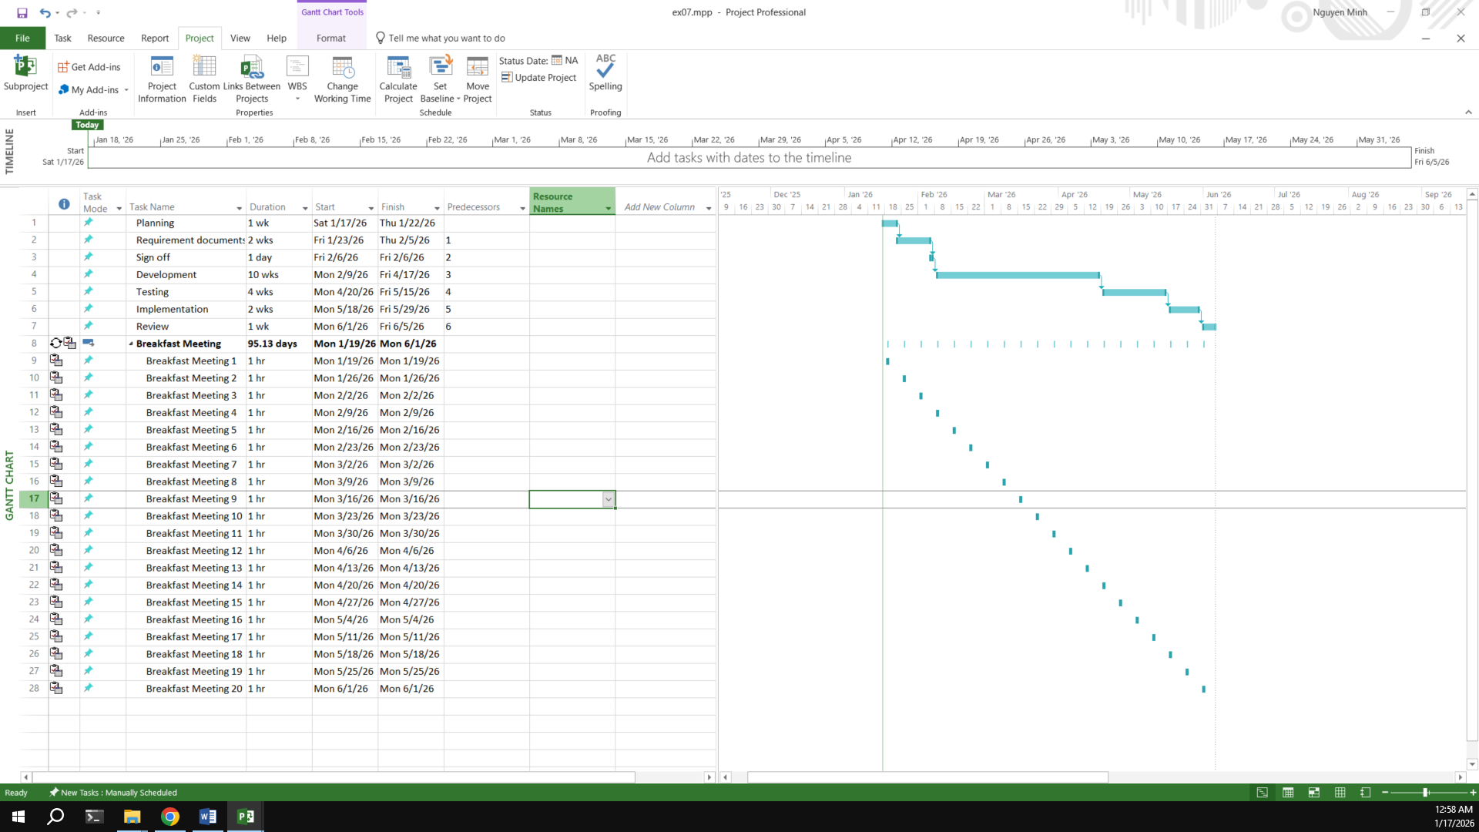

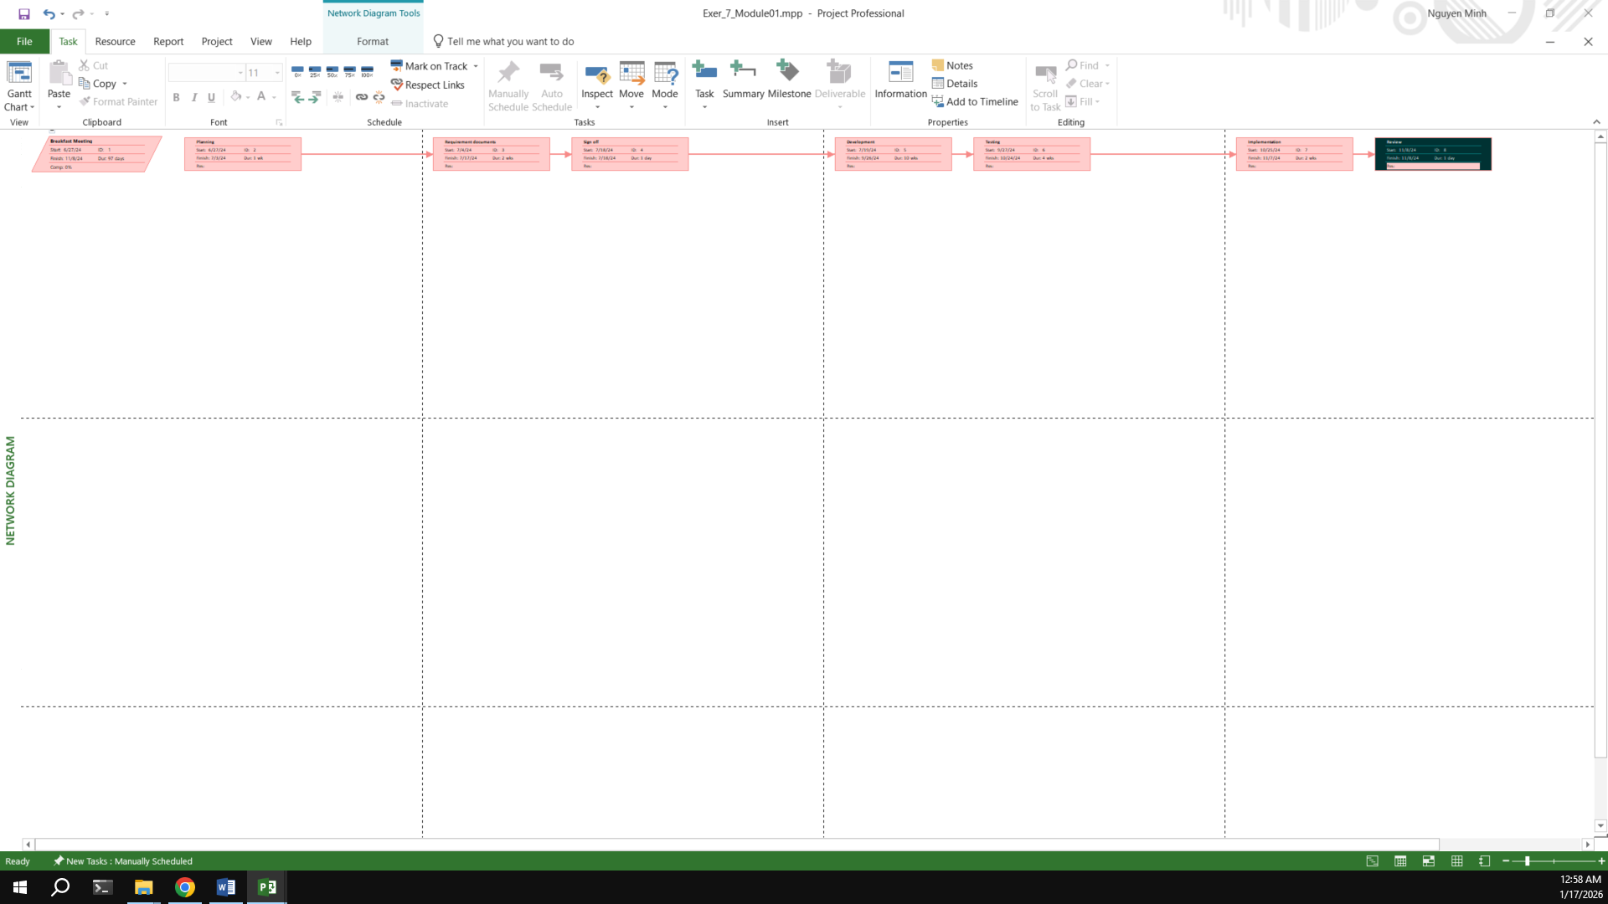

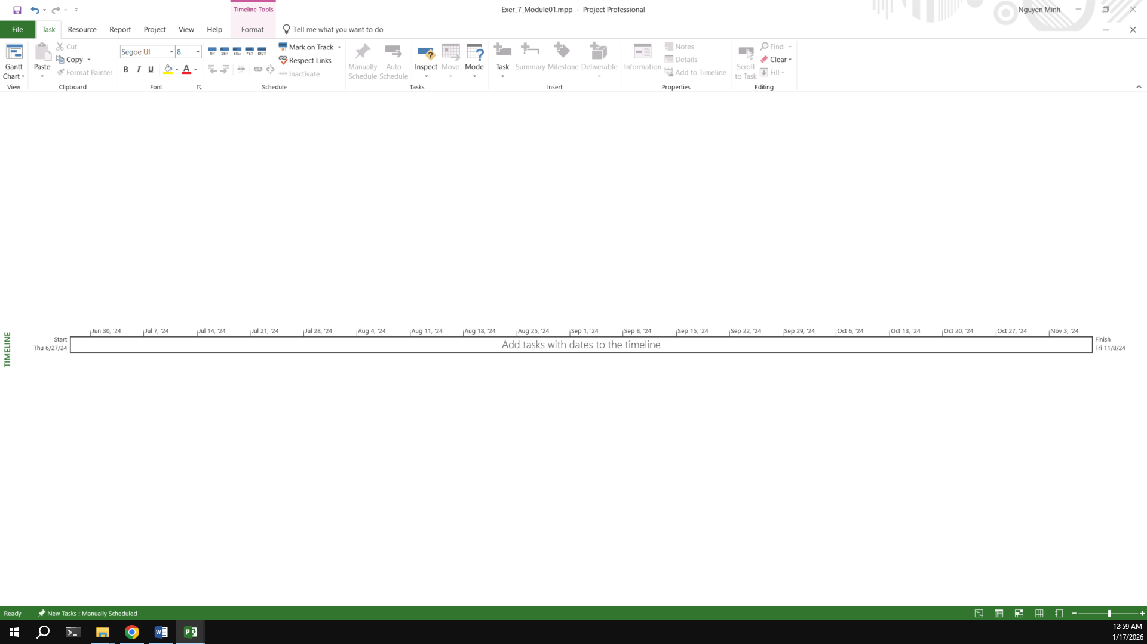

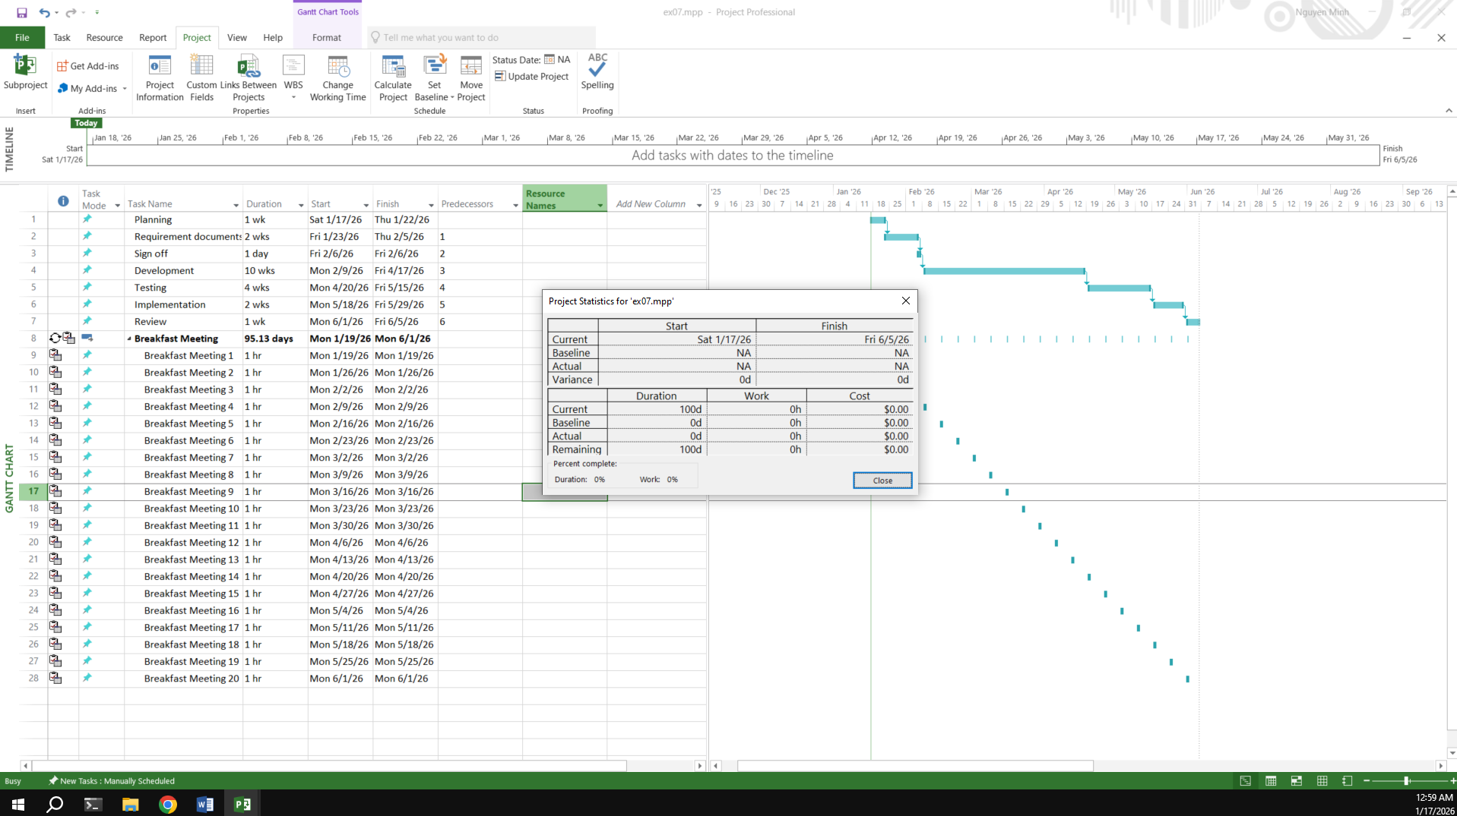

## Exercise 8: Travelling – tasks calendar

Travelling – task calendar You intend to travel from HCM to Kuala Lumpur, Bangkok and then, come back to HCM. Creating a plan for your trip.

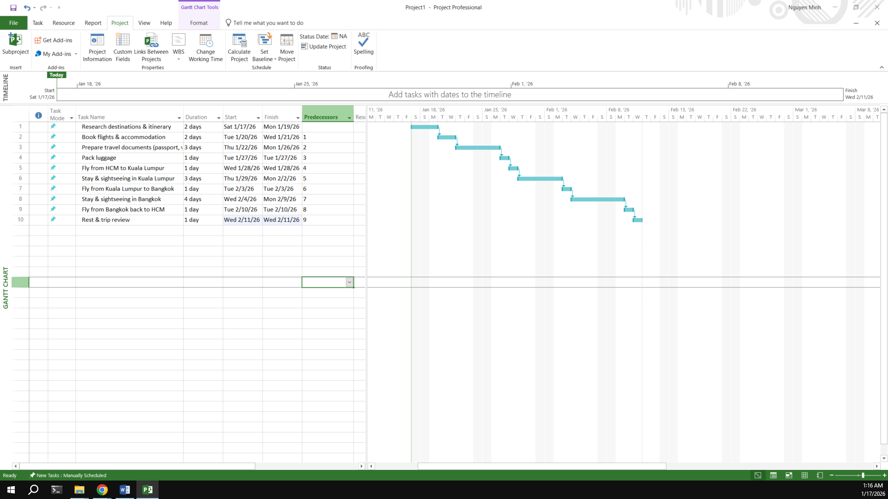

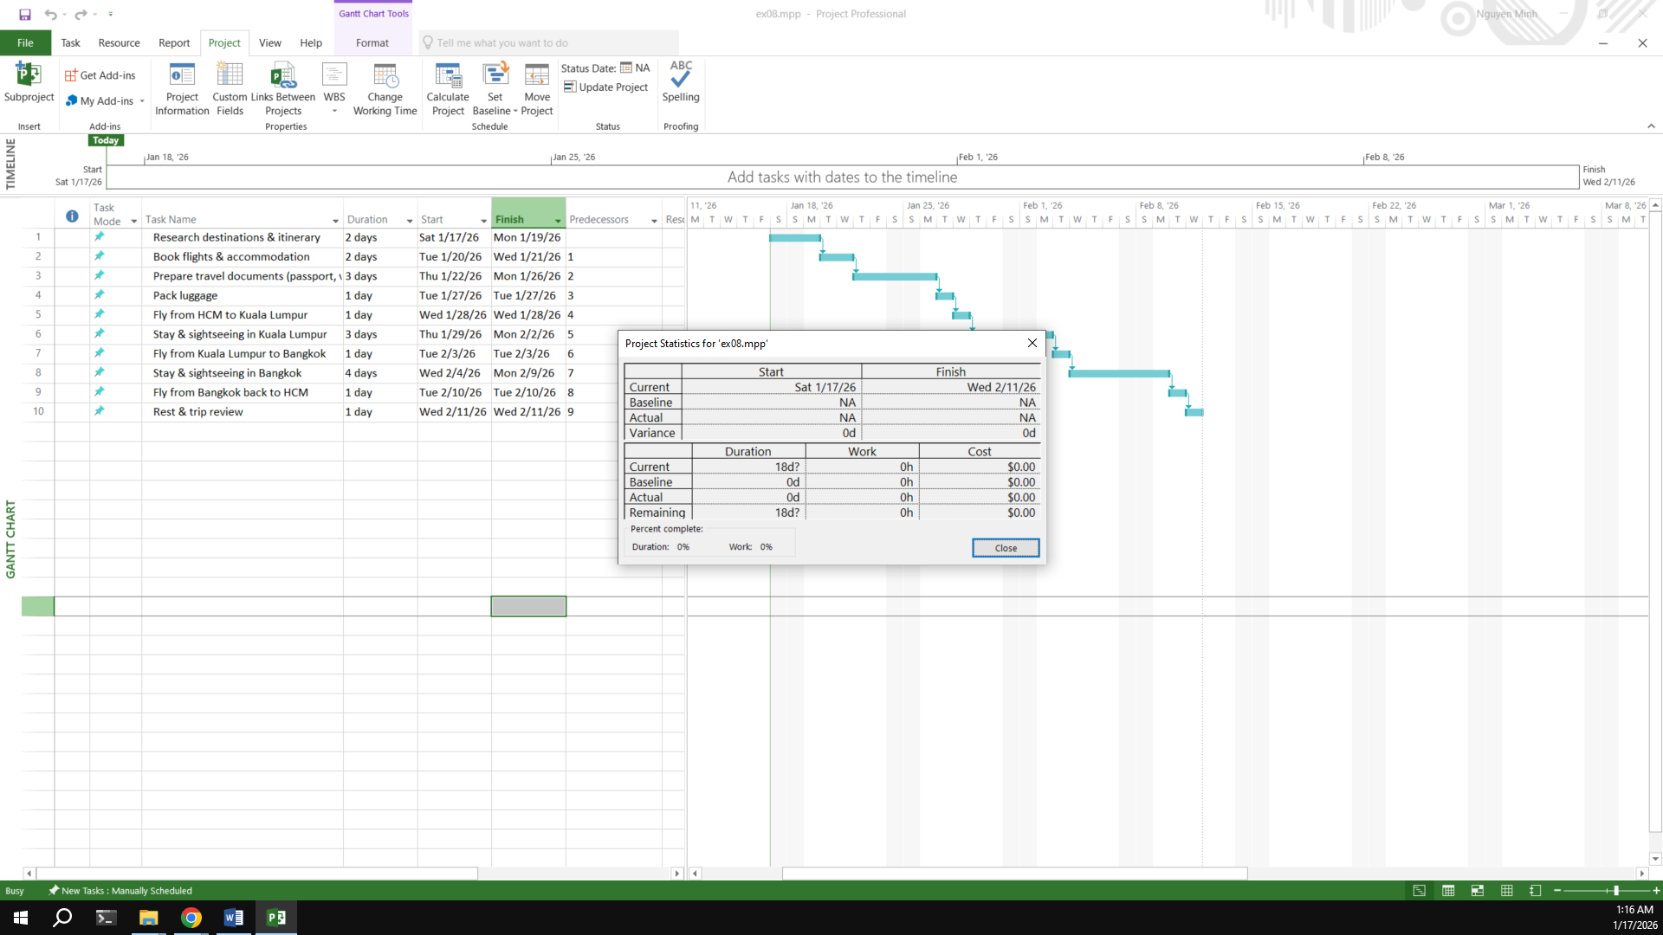

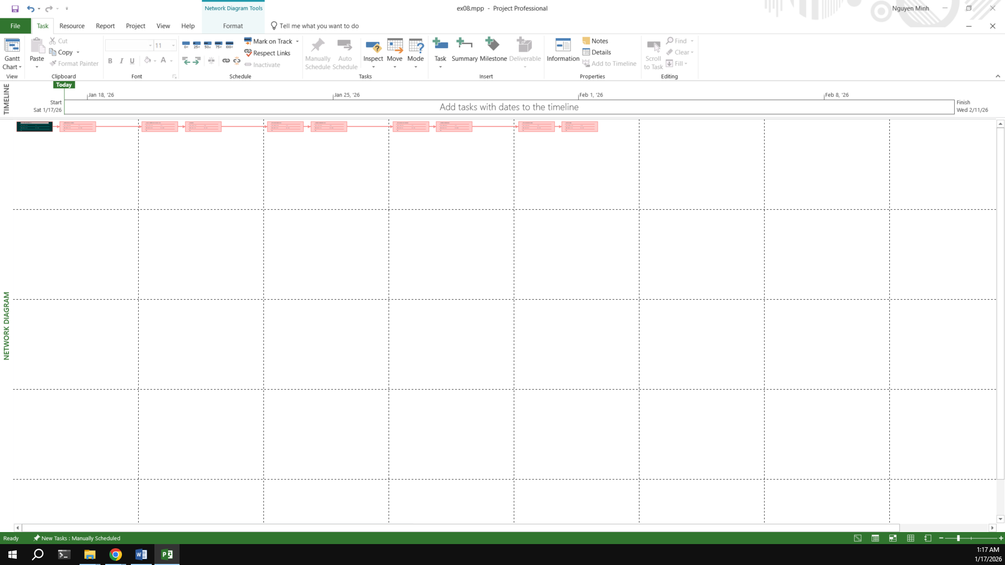

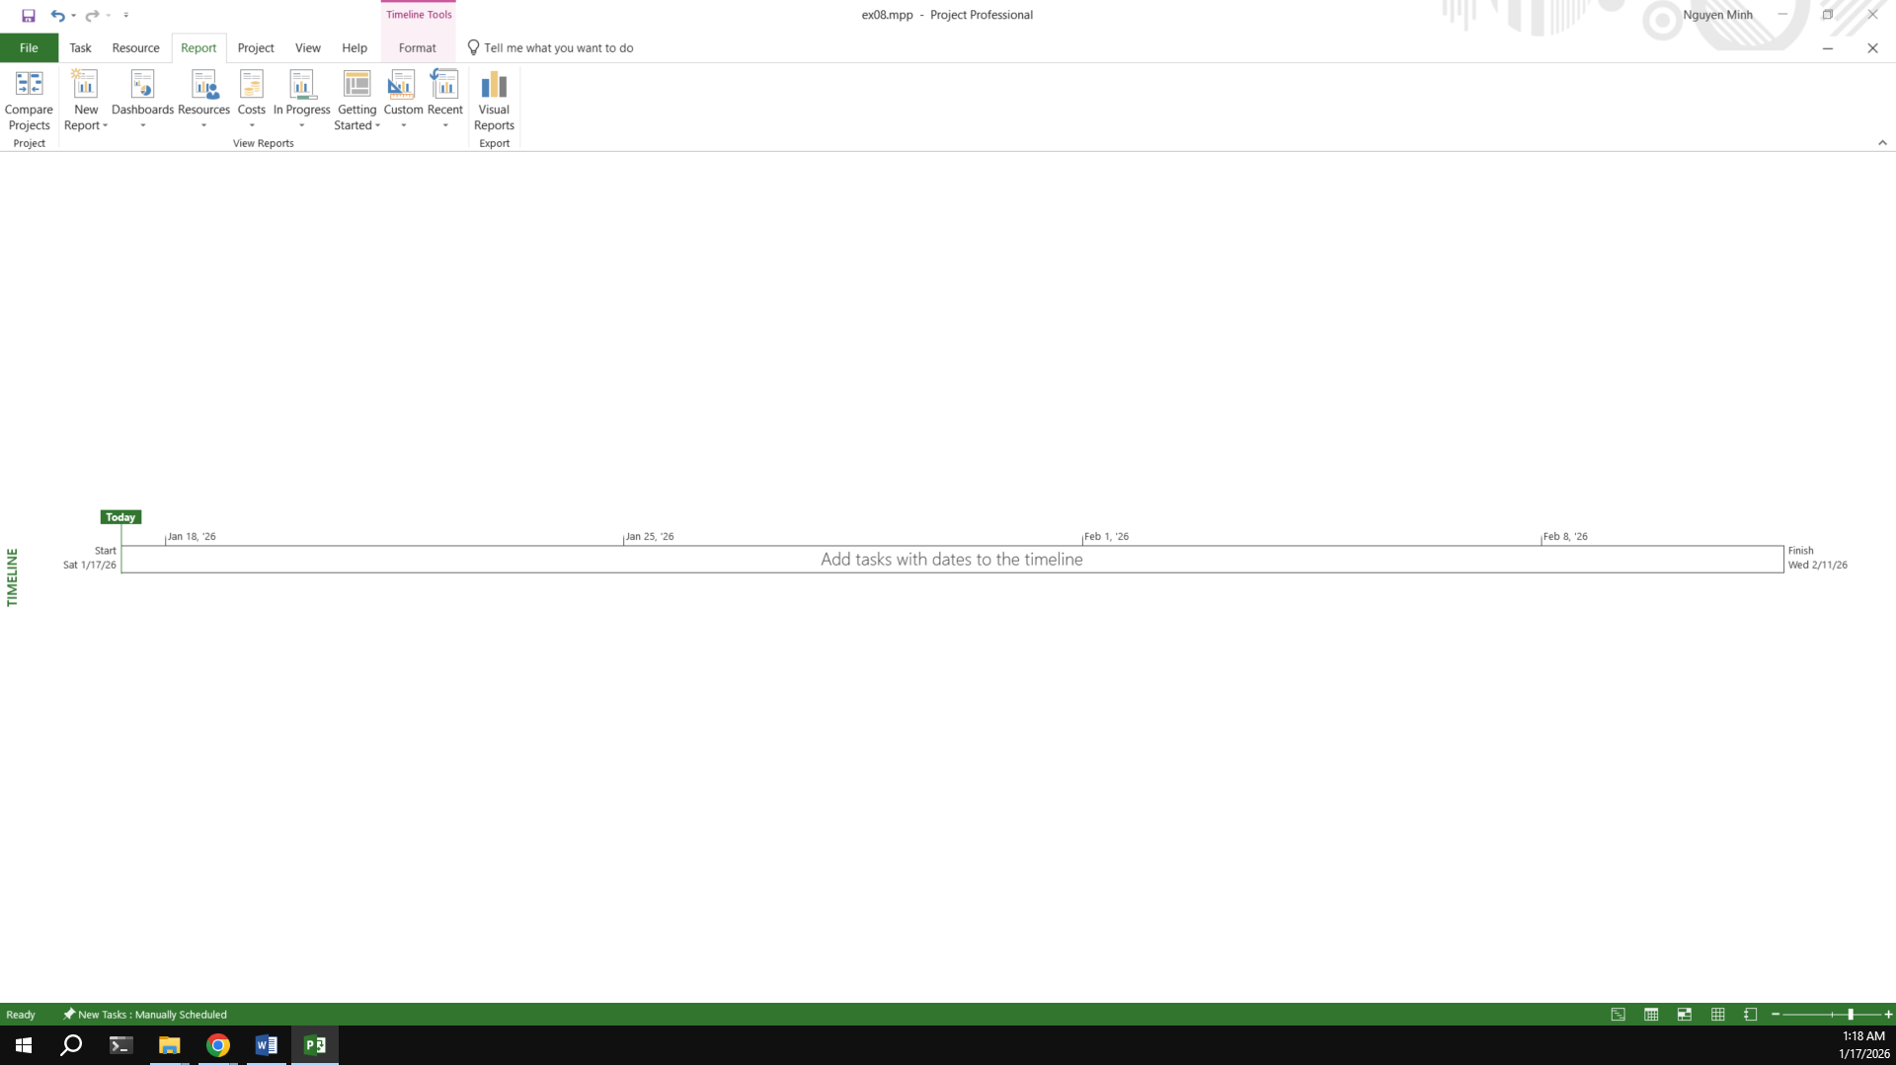

**- Hết -**